Here are the results of labwork 06:

**OLTP – Load External References – Normalization of Data**

Task 01 Install and expand load of external references T_Languages

After installing necessary scripts some objects (tables and views) were created; all necessary data was unloaded. List of All created tables and views (by their owners) are presented below.

*Tables of user U_DW_REFERENCES:*

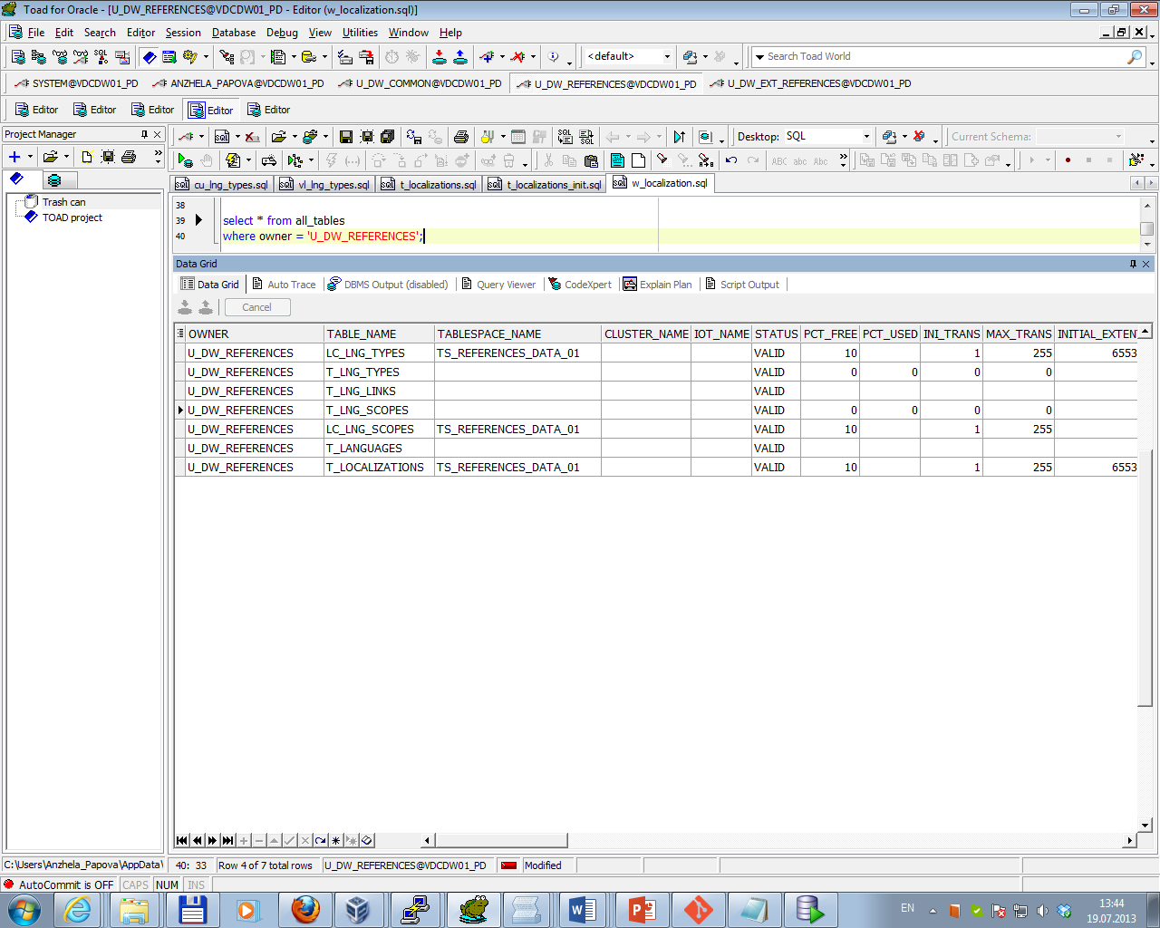

*Views of user U_DW_REFERENCES:*

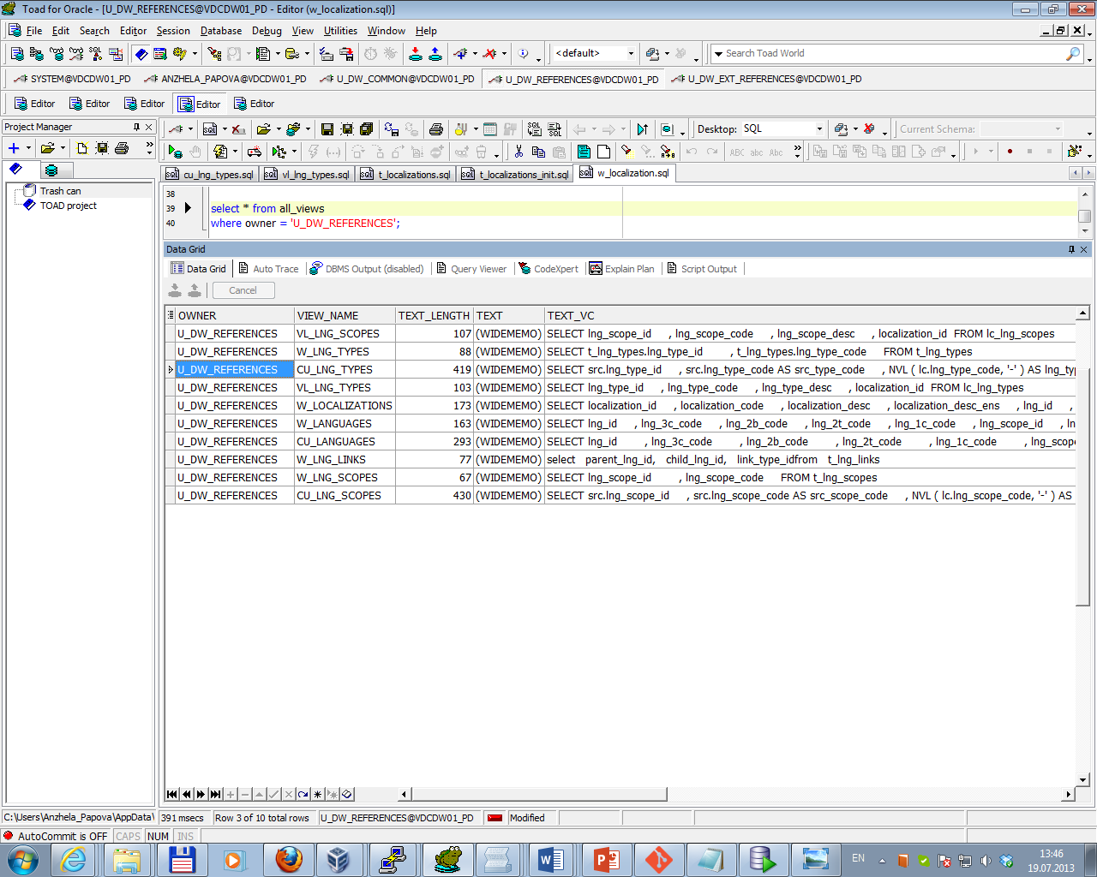

*Tables of user U_DW_EXT_REFERENCES:*

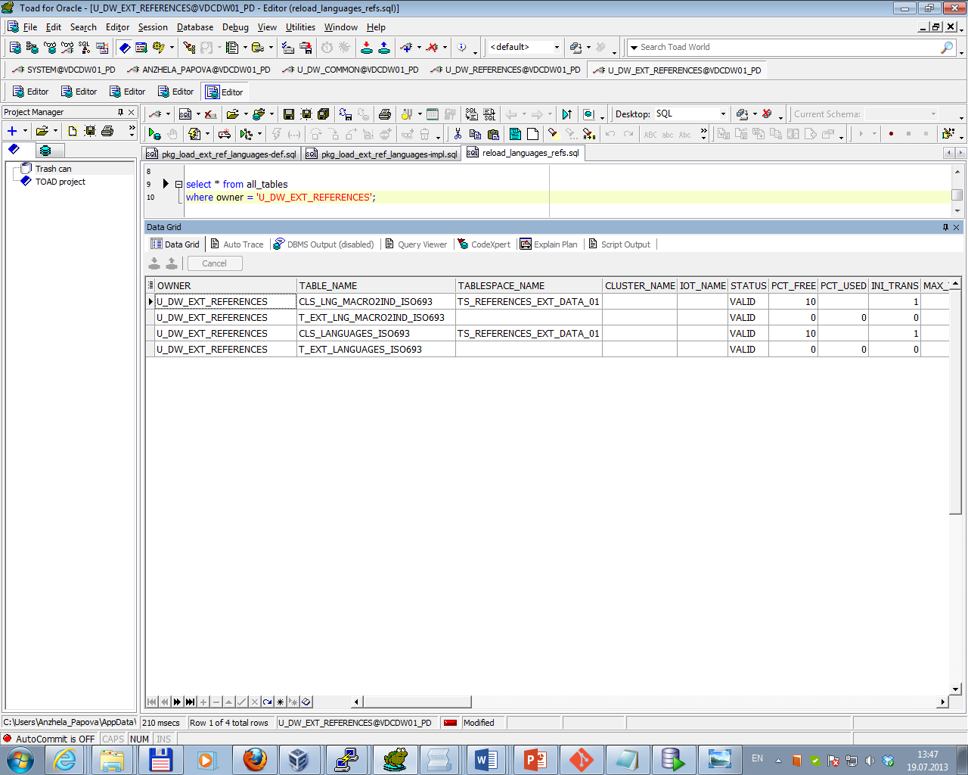

Sketch Diagram of loading external references is presented below.

Topic 06 - Star Schema Basics\External_References\ iso-639-3-Macro.tab

Topic 06 - Star Schema Basics\External_References\ iso-639-3.tab

Oracle Loader

External Table

t_ext_lng_macro2ind_

iso693

External Table

t_ext_languages_iso693

PROCEDURE load_cls_links_macro2

indiv

PROCEDURE load_cls_languages

cls_languages_iso693

cls_lng_macro2ind_iso693

The next screenshots illustrate result of data on objects.

*Data on t_localizations:*

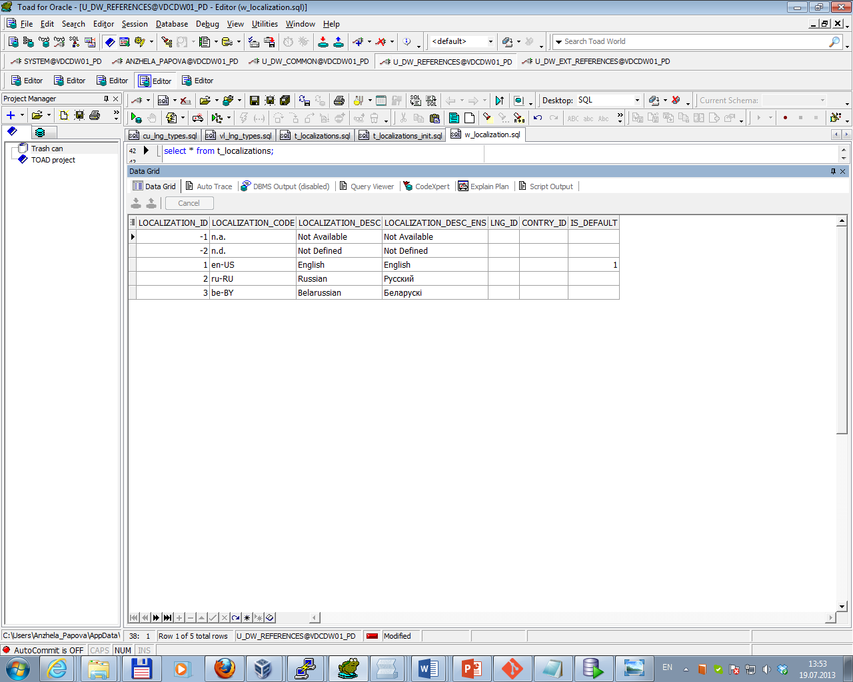

*Data on cu_languages:*

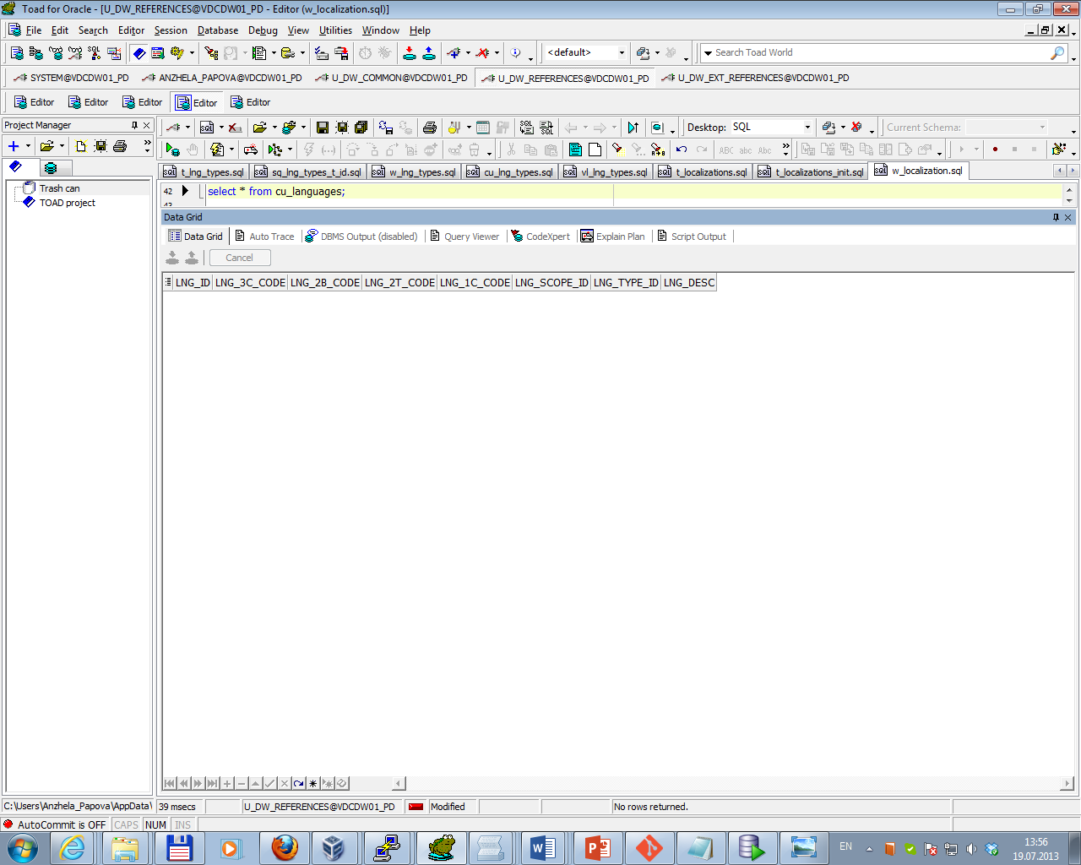

*Data on w_lng_links:*

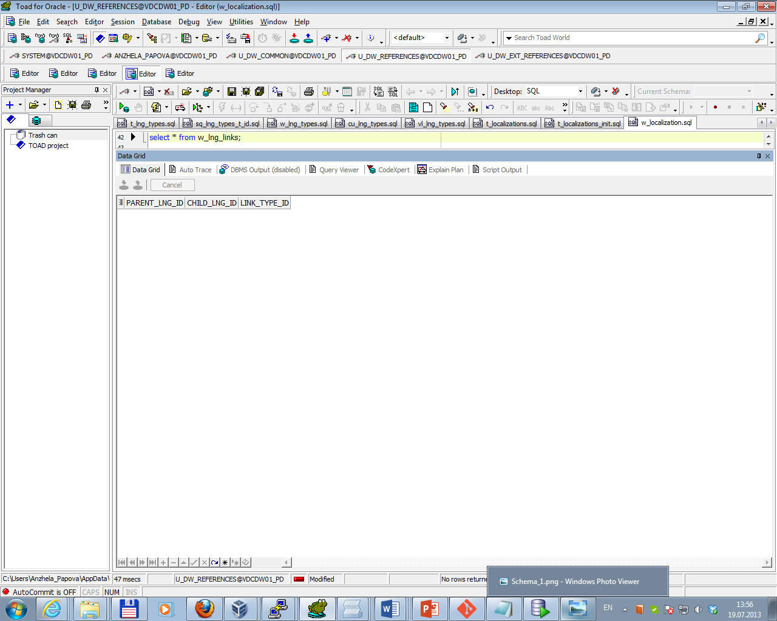

*Data on cu_lng_scopes:*

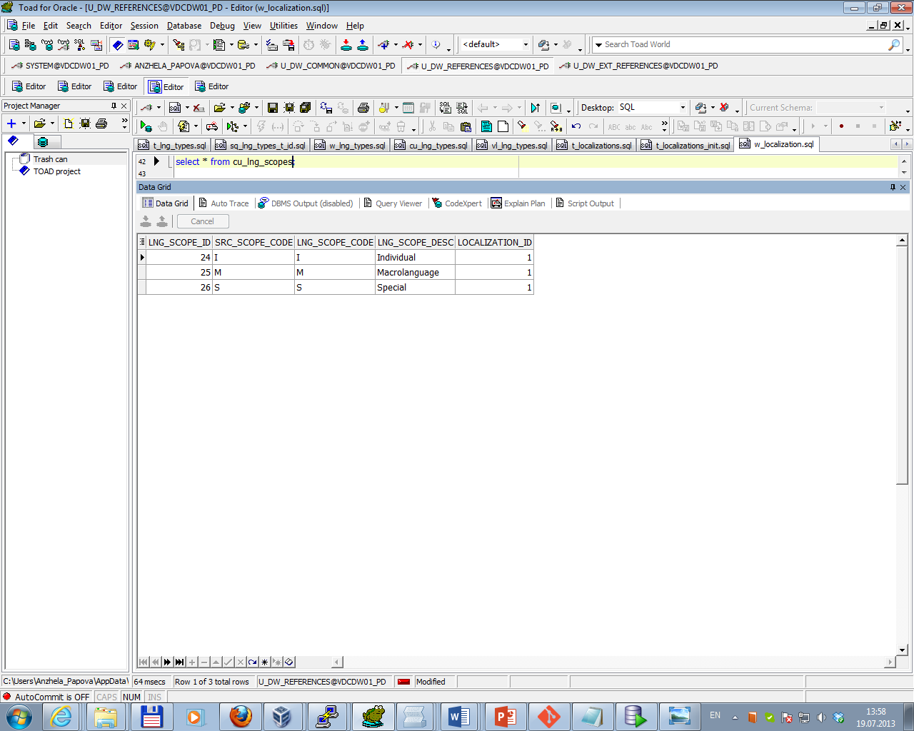

*Data on cu_lng_types:*

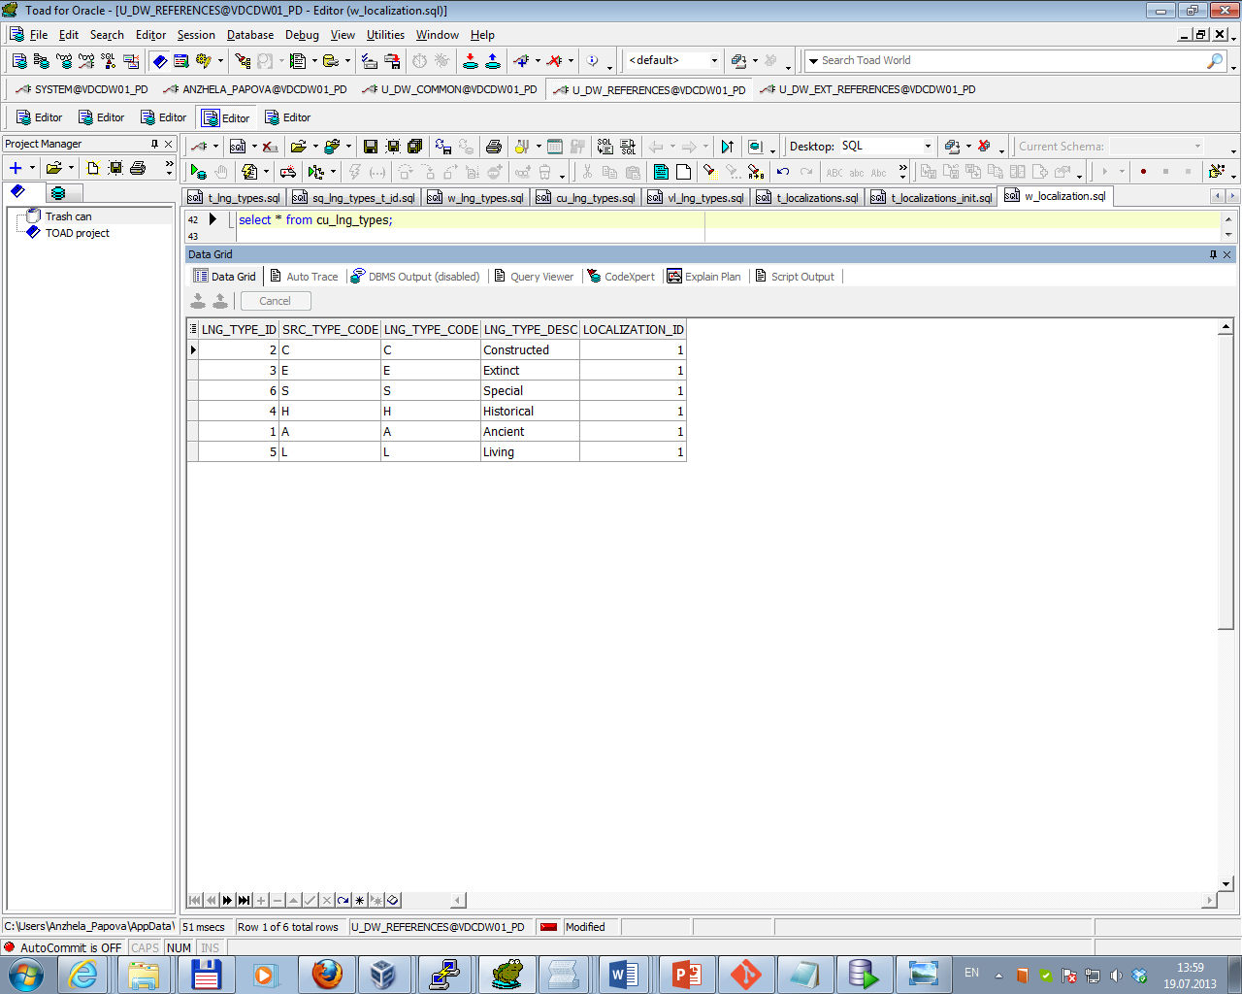

The Physical diagram of T_Languages is presented below.

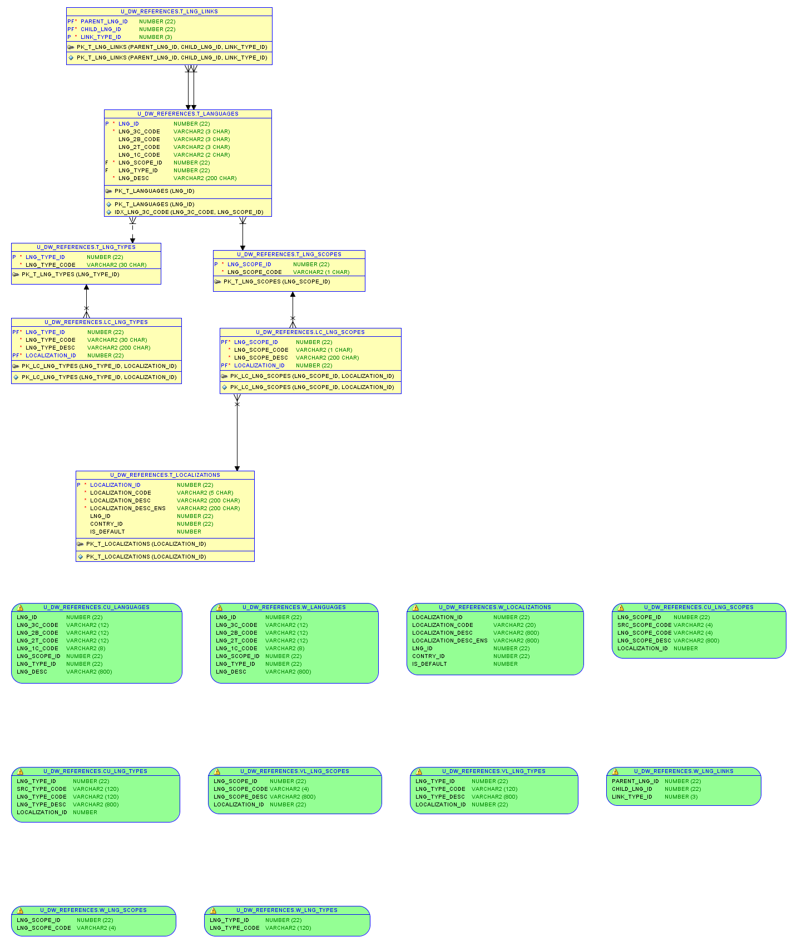

Task 02 Create load process for External references T_Countries

After installing necessary scripts some objects (tables and views) were created; all necessary data was unloaded. List of All created tables and views (by their owners) are presented below.

*Tables of user U_DW_REFERENCES:*

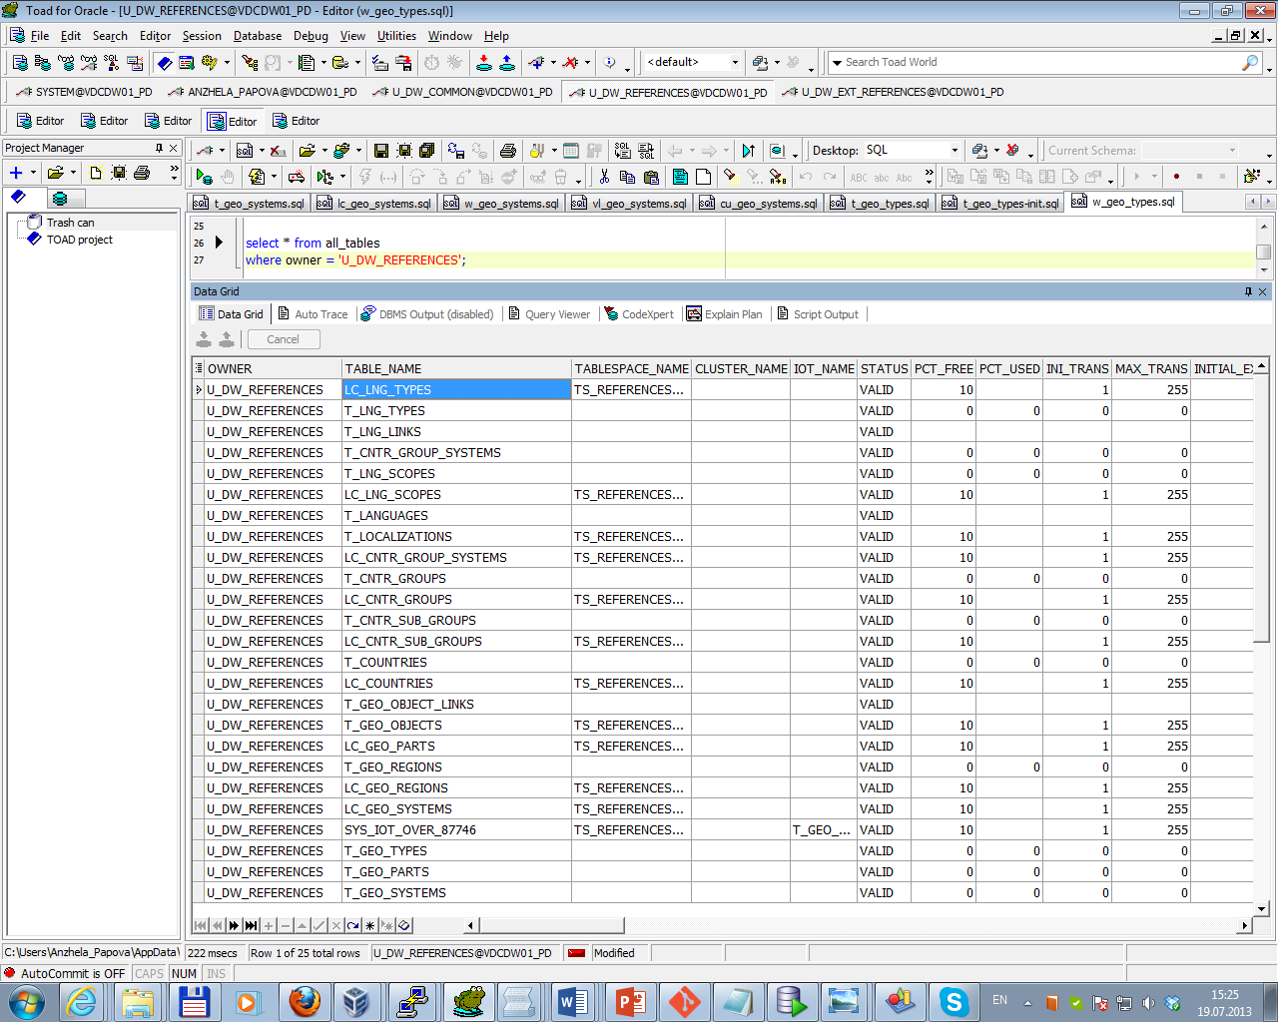

*Views of user U_DW_REFERENCES:*

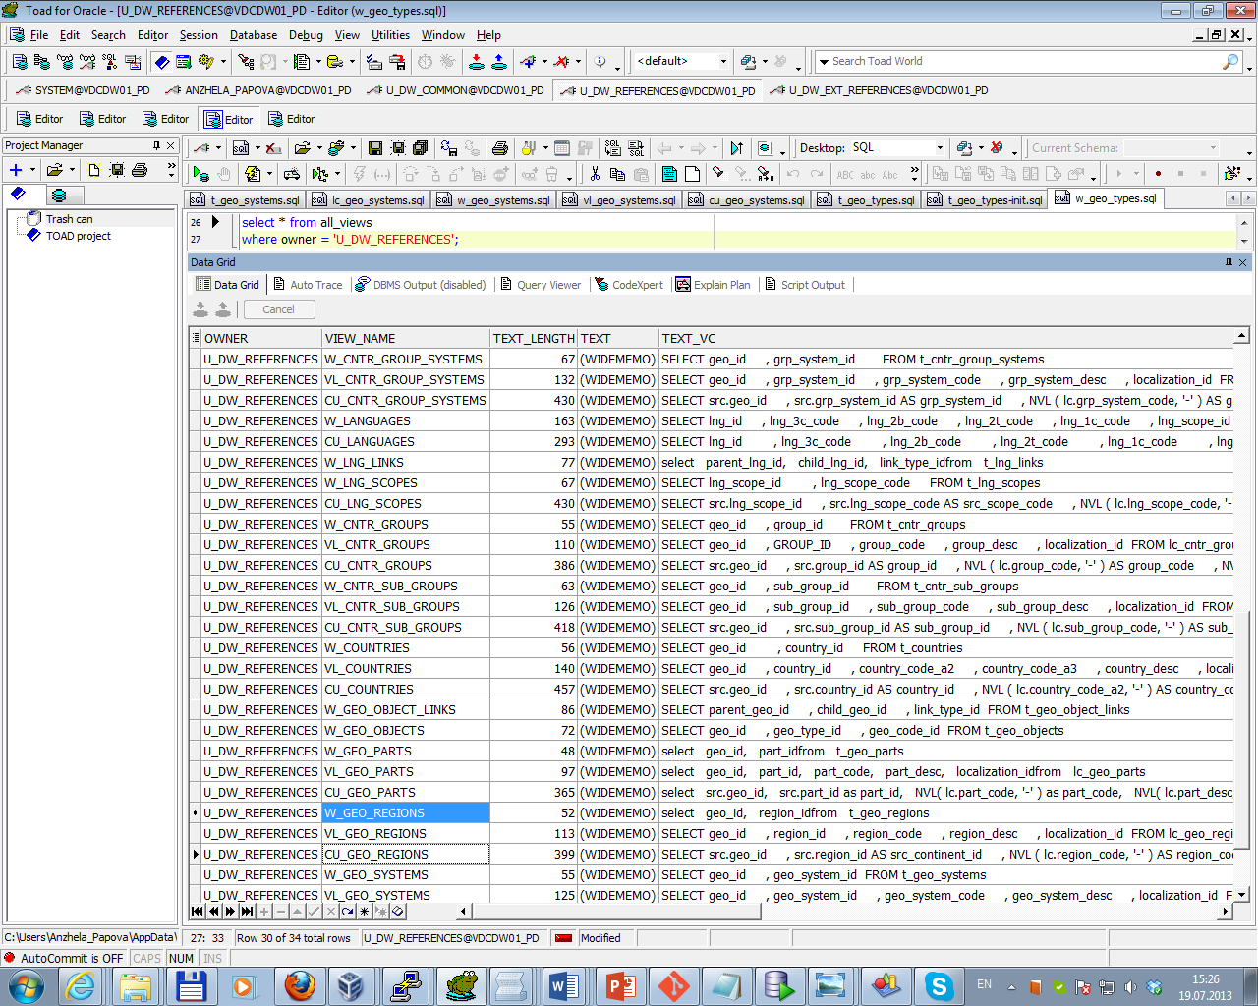

*Tables of user U_DW_EXT_REFERENCES:*

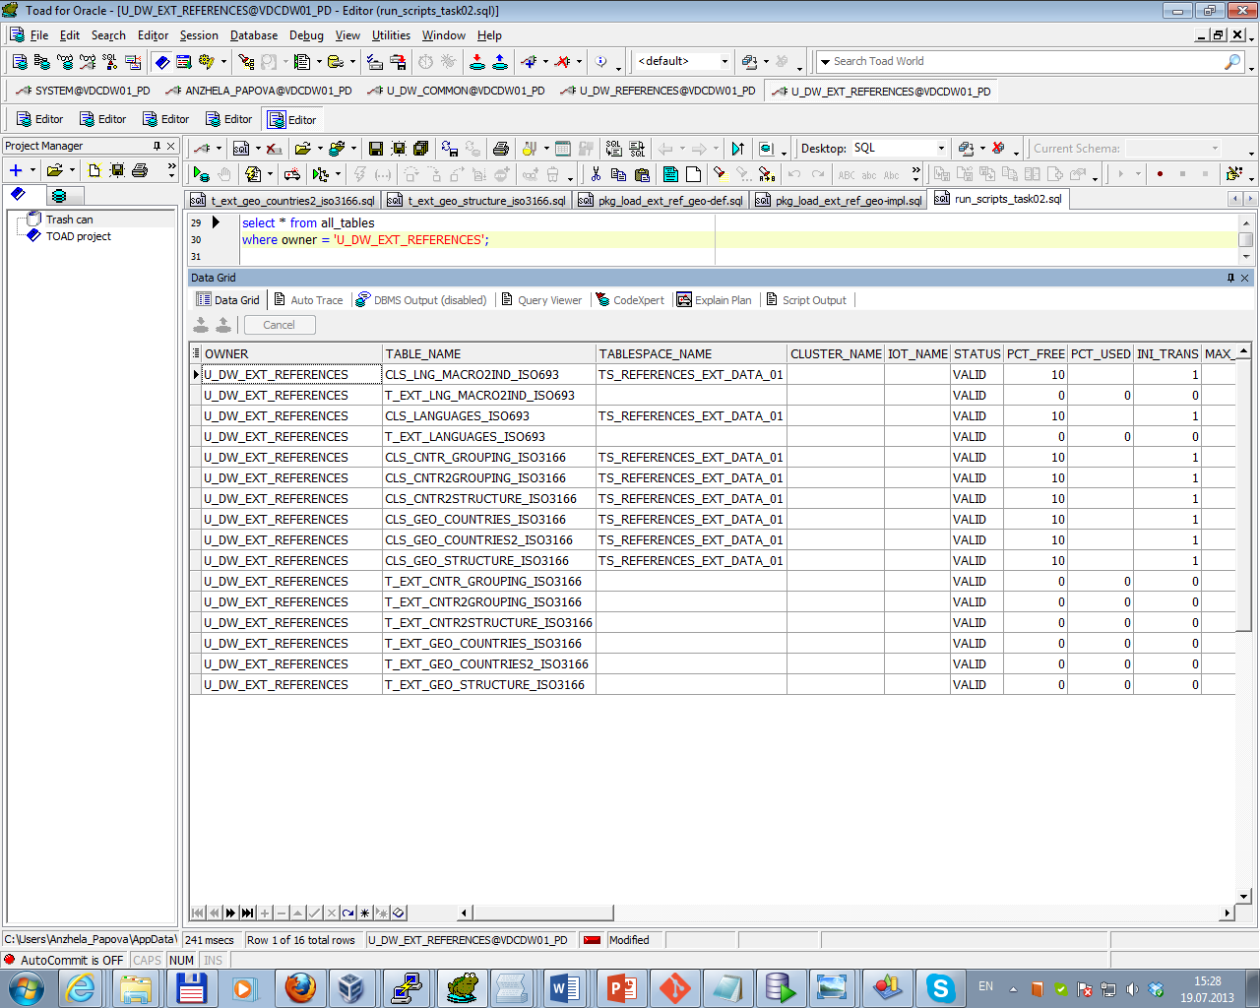

Sketch Diagram of loading external references is presented below.

Topic 06 - Star Schema Basics\ External_References\ iso_3166.tab

Topic 06 - Star Schema Basics\ External_References\ iso_3166_2.tab

Topic 06 - Star Schema Basics\ External_References\ iso_3166_geo_un.tab

Topic 06 - Star Schema Basics\ External_ References\ iso_3166_ geo_un_contries.tab

Topic 06 - Star Schema Basics\ External_ References\ iso_3166_ groups_un.tab

Topic 06 - Star Schema Basics\ External_ References\ iso_3166_ groups_un_contries.tab

Oracle Loader

External Table

t_ext_cntr2 grouping_iso3166

External Table

t_ext_cntr_

grouping_iso3166

External Table

t_ext_geo_

structure_iso3166

External Table

t_ext_geo_

countries2_iso3166

External Table

t_ext_cntr2

structure_iso3166

External Table

t_ext_geo_

countries_iso3166

PROCEDURE load_cls_countries2

groups

PROCEDURE load_cls_countries_

grouping

PROCEDURE load_cls_geo_

structure

PROCEDURE load_cls_geo_

structure2cntr

PROCEDURE load_cls_languages_alpha2

PROCEDURE load_cls_languages_alpha3

cls_cntr_ grouping_ iso3166

cls_cntr2 grouping_ iso3166

cls_geo_

structure_

iso3166

cls_cntr2

structure_

iso3166

cls_geo_

countries2_iso3166

cls_geo_

countries_

iso3166

The next screenshots illustrate result of data on objects.

*Data on lc_geo_parts:*

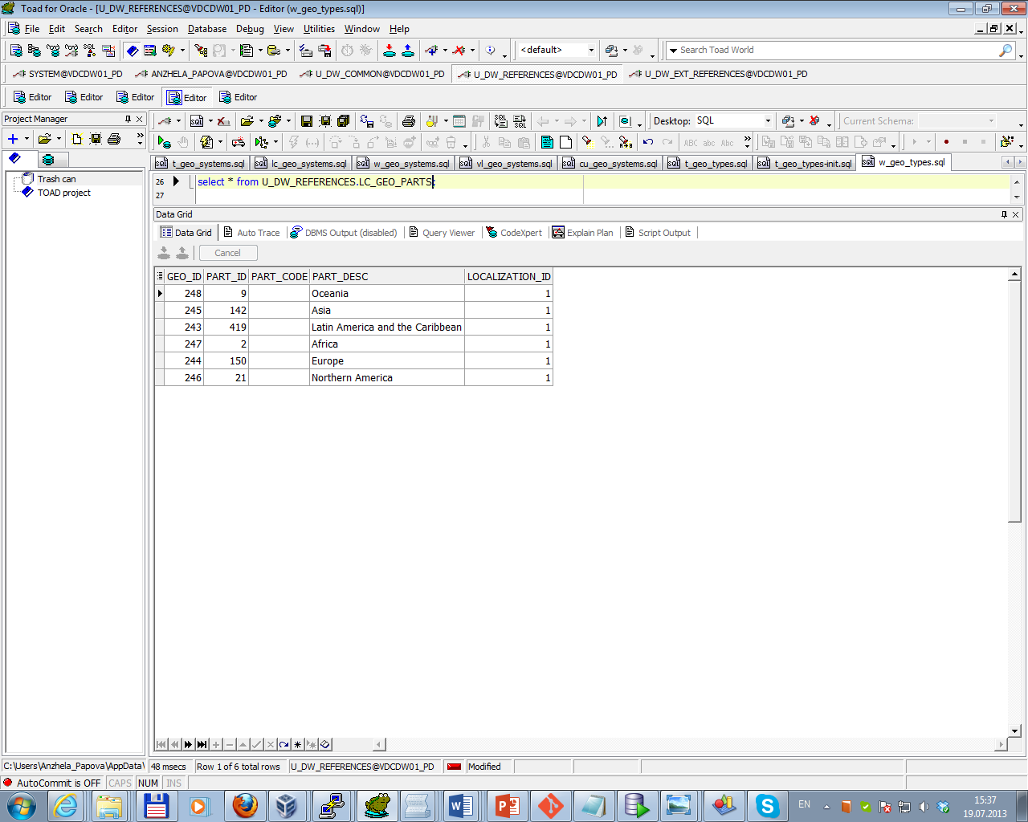

*Data on t_geo_types:*

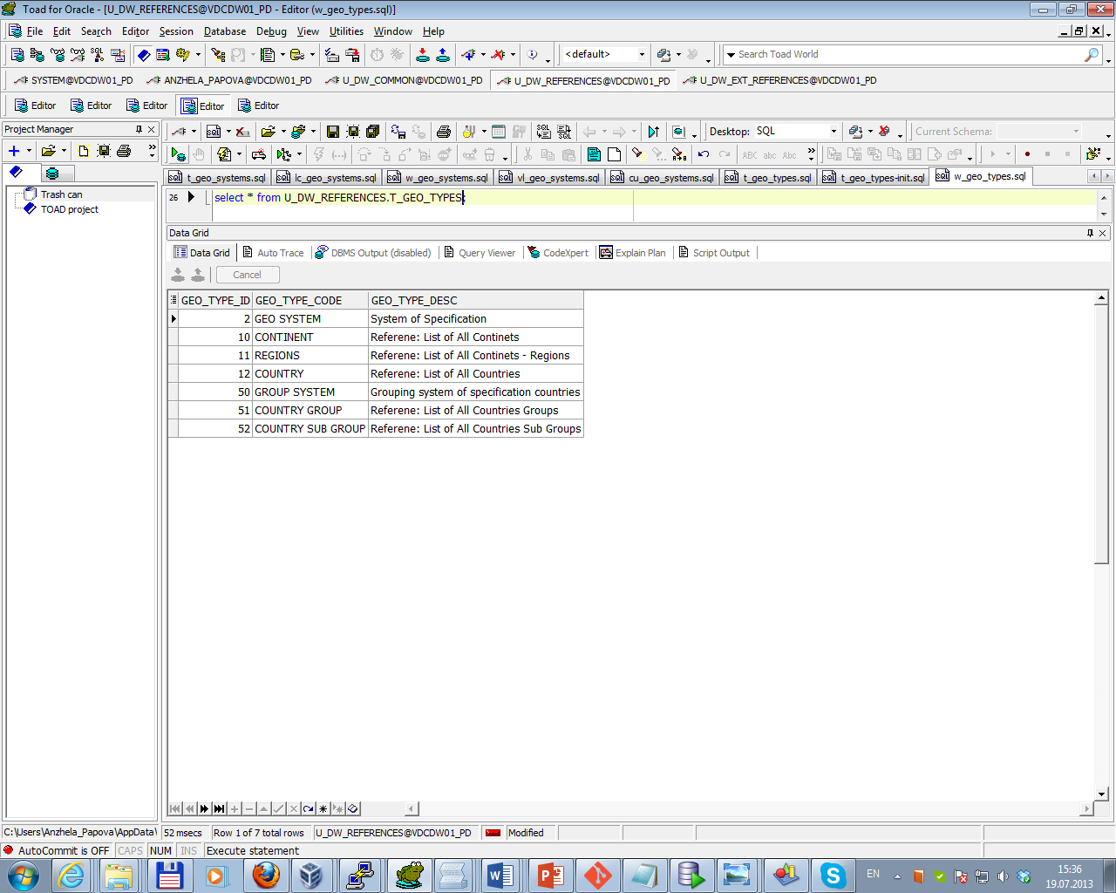

*Data on lc_countries:*

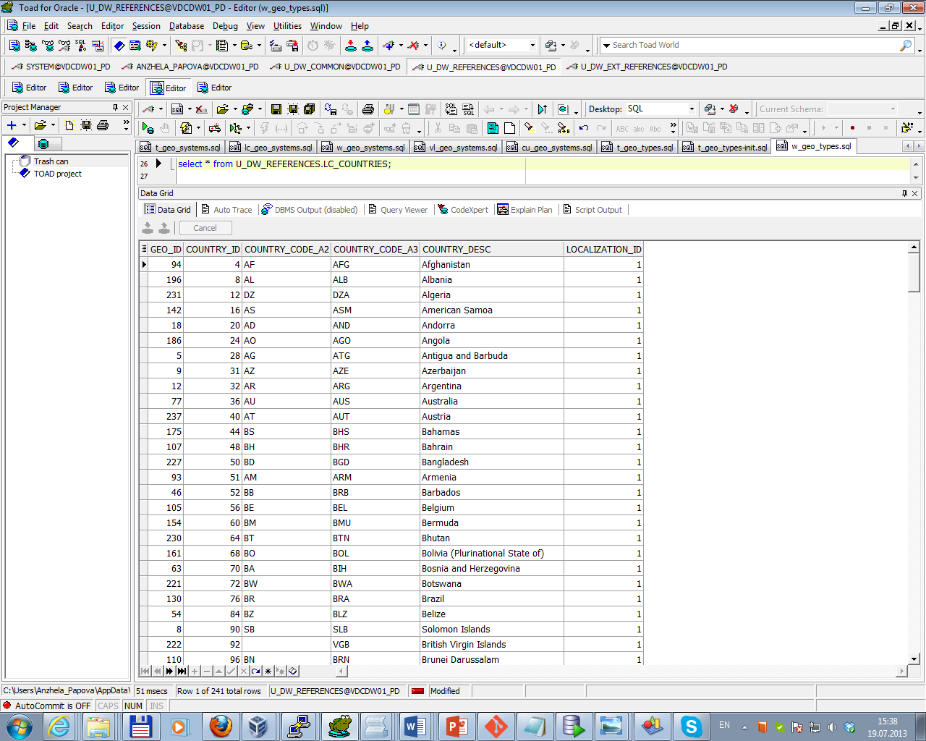

*Data on lc_geo_regions:*

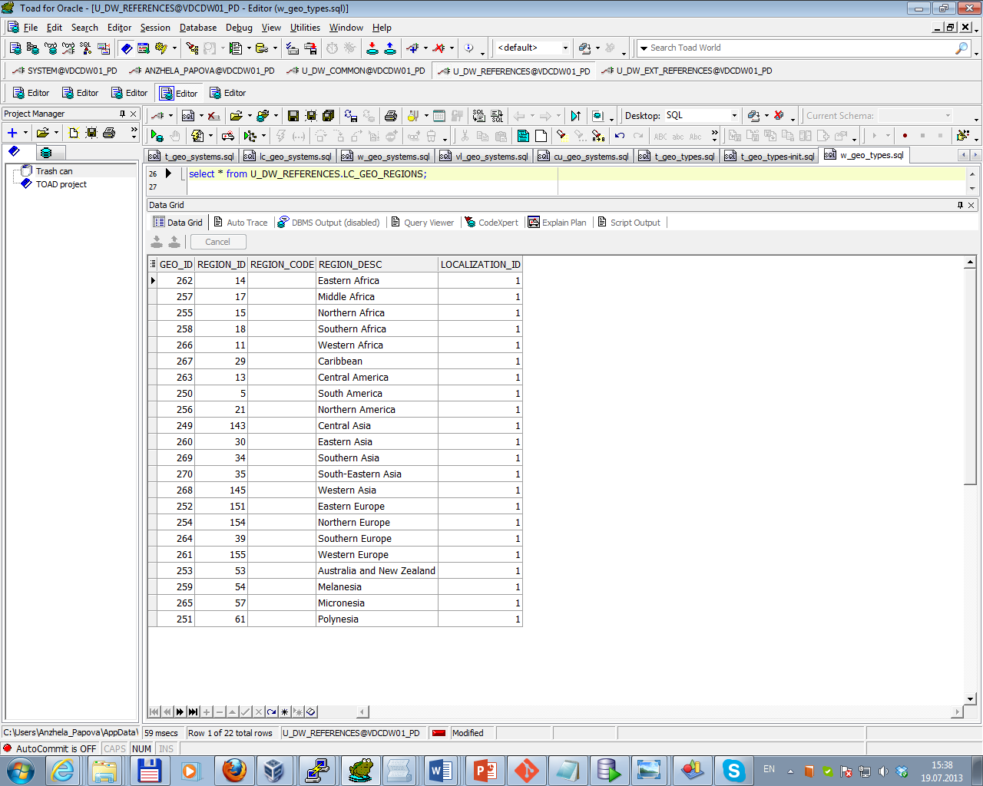

*Data on lc_cntr_sub_groups:*

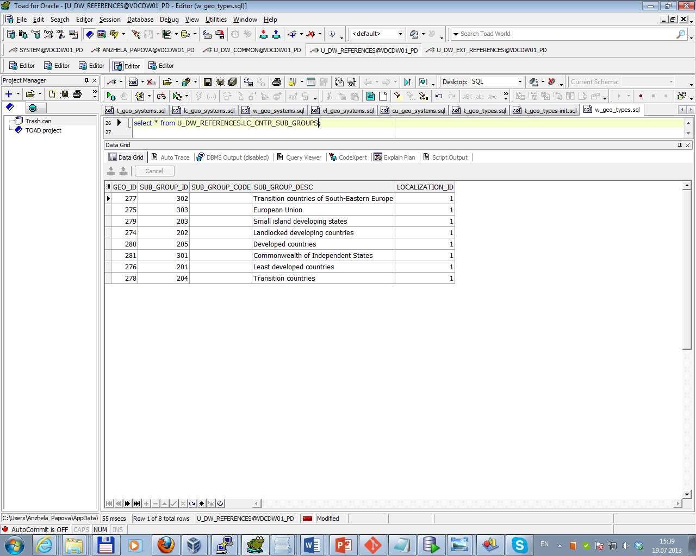

*Data on lc_cntr_groups:*

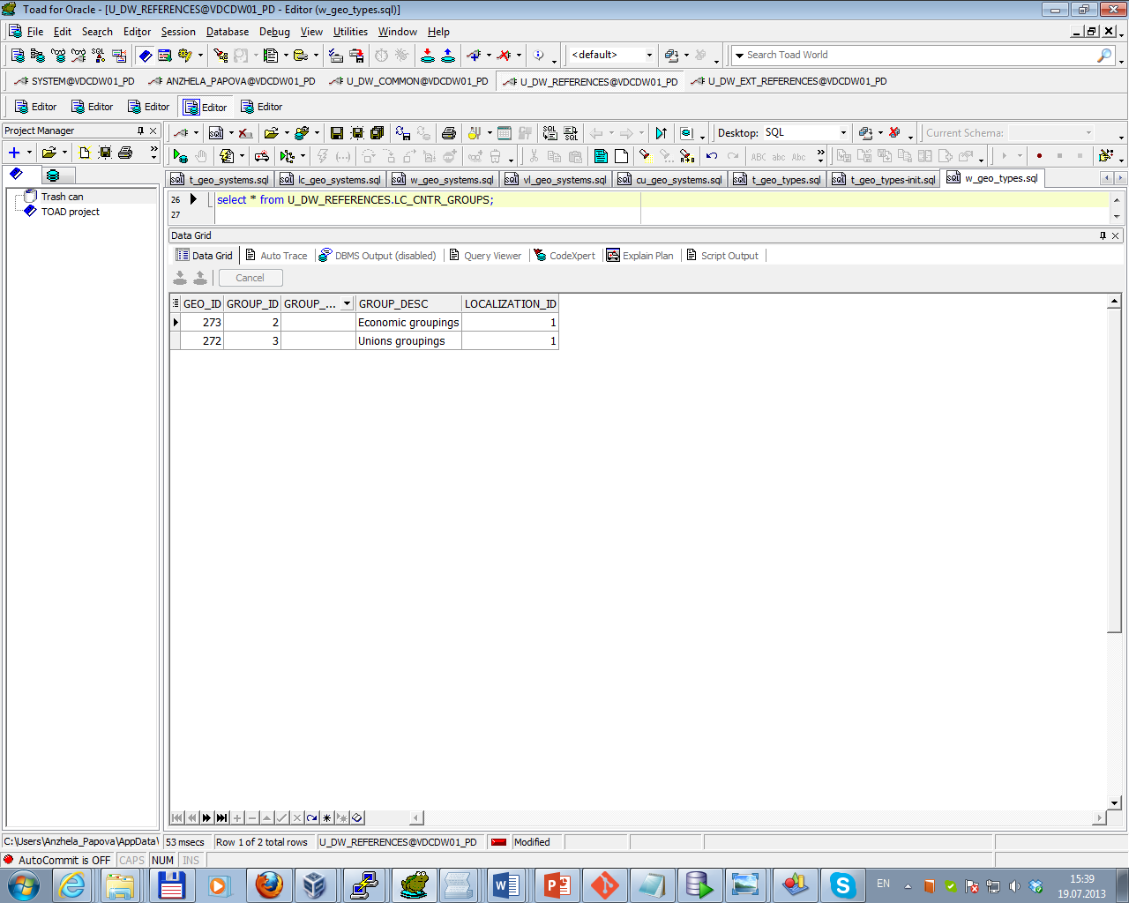

*Data on lc_geo_systems:*

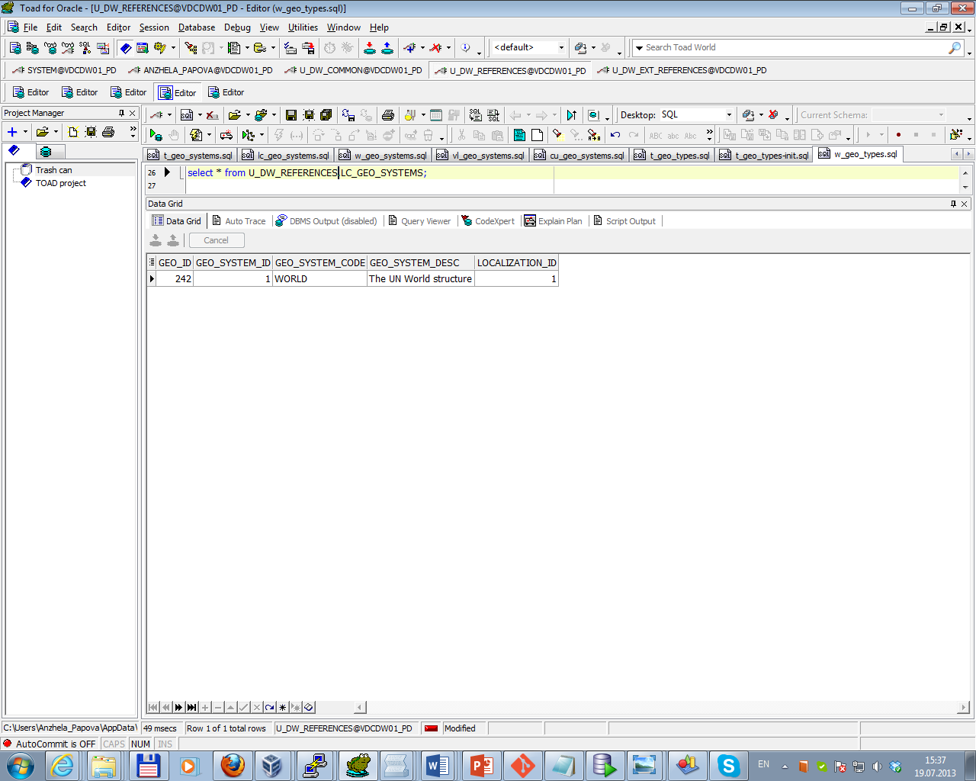

*Data on lc_geo_systems:*

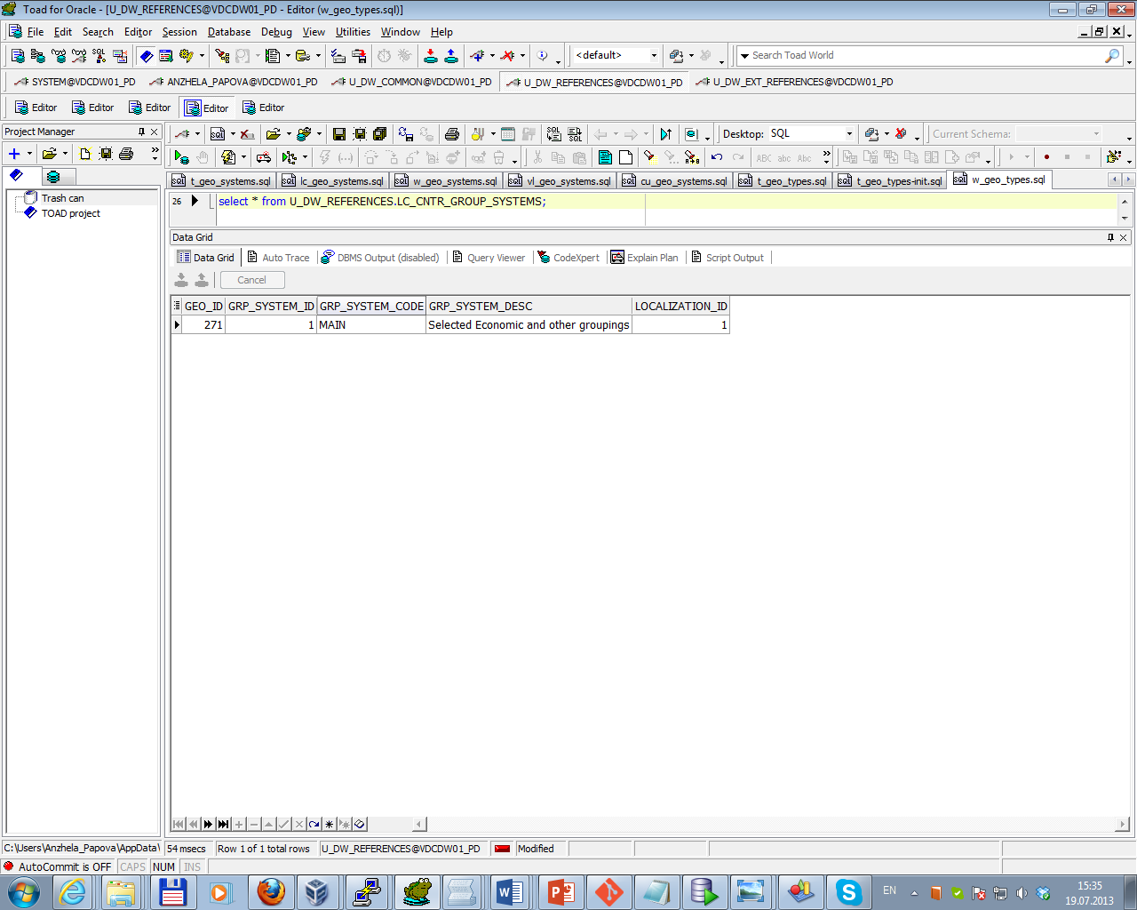

The Physical diagram of T_Countries is presented below.

